Growth Hormone (GH)

**How is it produced?**

GH is produced by anterior pituitary glands called somatrophs, which release 1 to 2 milligrams of the hormone per day.

**What is its function?**

**GH stimulates protein synthesis and increases fat breakdown to provide the energy necessary for tissue growth. It stimulates the growth of essentially all tissues of the body.**

**What are the consequences of too much or too little GH?**

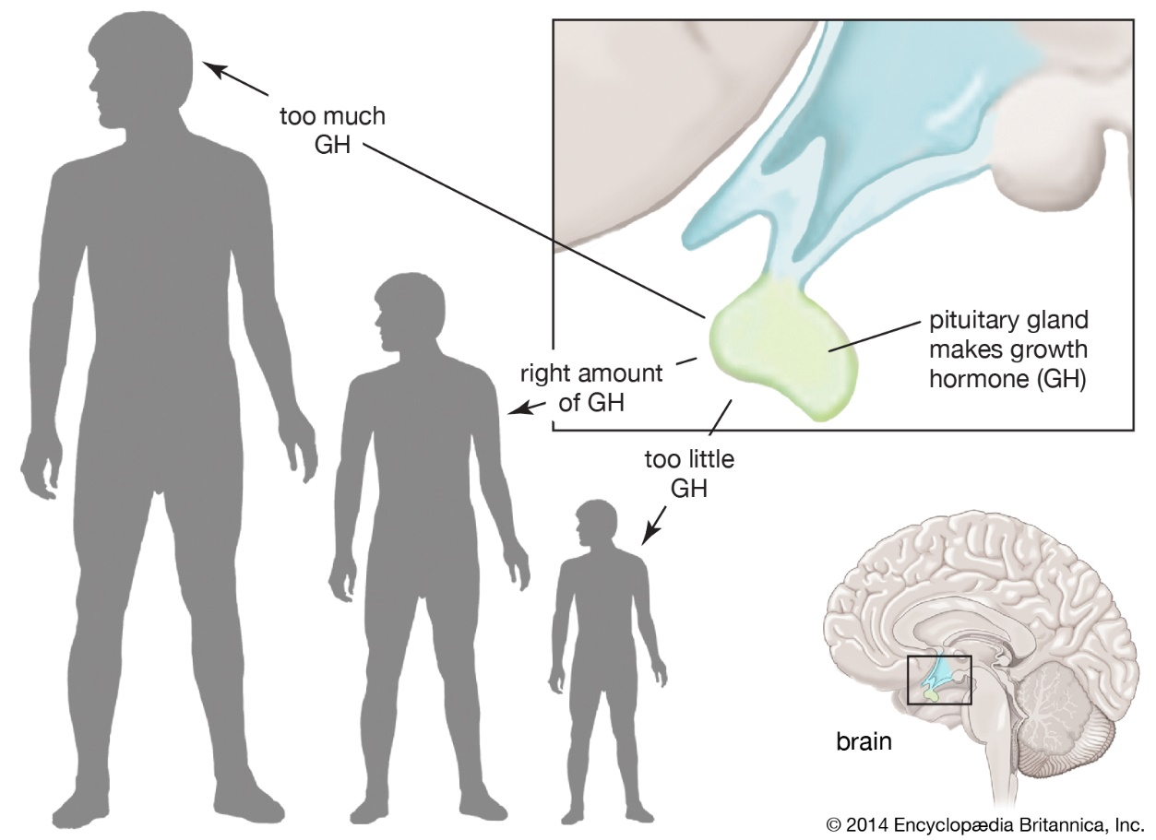

**If you produce too little GH, you will have something called** growth hormone deficiency (GHD), also known as dwarfism or pituitary dwarfism. Children with GHD have abnormally short stature with normal body proportions. GHD can be present at birth (congenital) or develop later (acquired).

**If you, on the other hand, produce too much GH, you will have** acromegaly, also known as gigantism. Too much of this hormone causes bones, cartilage, body organs, and other tissues to increase in size.